**Name: Sandy Hany Saad Hanna**

**B.N: 381**

**Date : 30/5/2020**

**Topic:** **programming languages**

**Github link :** [**https://github.com/sandyhany/Ece001**](https://github.com/sandyhany/Ece001)

**Github page :** [**https://sandyhany.github.io/Ece001**](https://sandyhany.github.io/Ece001)

**Application brief:**

(Programming language), is a set of commands, written according to rules determined by the programming language, and then these commands go through several stages until they are executed on Computer programming languages allow us to give instructions to a computer in a language the computer understands. Just as many human-based languages exist, there are an array of computer programming languages that programmers can use to communicate with a computer. The portion of the language that a computer can understand is called a “binary.” Translating programming language into binary is known as “compiling.” Each language, from C Language to Python, has its own distinct features, though many times there are commonalities between programming languages.

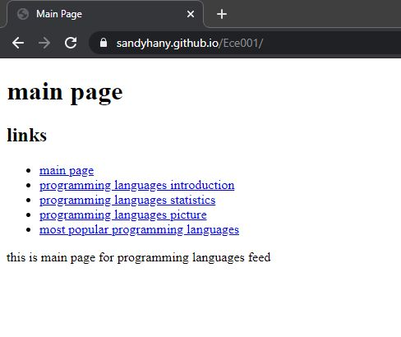**Screenshots:**

